**Information System Management Lab**

**BCOM 307**

**Assignment #2**

***Submitted by:***

**Name:** YASH JAIN

**Enrollment No:** 03914788818

**Semester:** 5th Sem

**Class:** B.Com(H)

**Section**: BCom 5A

**Date of Submission**: 06/09/2021

***Submitted to:***

**Praveen Kumar Singh**

**Assistant Professor, MAIMS**



**Department of Commerce**

**Maharaja Agrasen Institute of Management Studies**

**Affiliated to Guru Gobind Singh Indraprastha University, Delhi**

**Sector -22, Rohini, Delhi -110086, India; www.maims.ac.in**

Maharaja Agrasen Institute of Management Studies

Affiliated to GGS IP University; Recognized u/s 2(f) of UGC Recognized by Bar Council ofIndia; ISO 9001: 2015

Certified Institution Sector 22, Rohini, Delhi -110086, India; [www.maims.ac.in](http://www.maims.ac.in/)

Department of Commerce

Academic Year: 2020-21

Semester: Vth

# Assignment No.2

# Unit No: 1

**Course/ Subject Code:** BCOM 307 **Subject Title: Information System Management Lab**

# Issue Date: Last Date of Submission:

**Instructions for Students:**

# All Questions are Compulsory.

1. The student should attach proper cover page for each assignment clearly mentioning the Assignment No.
2. Each assignment should be prepared by the student individually with proper explaination and screenshots.
3. A4 size ruled sheets should be used for the assignment.
4. Assignment pages should be serially numbered at the bottom of page.

***During online education mode, upload scanned copy of the complete assignment including cover page latest by due date.***

|  |  |  |
| --- | --- | --- |
| **Question No.** | **Question** | **CO**  **No.** |
| 1 | Create a table called “client_master” that contains five columns:   1. Client_no 2. Client_name 3. Address 4. City 5. Pincode 6. State 7. Baldue | **CO1** |
| 2 | Insert any 5 rows in the above columns |
| 3 | Select the whole table |
| 4 | Display all the details where city is ‘Delhi’. |
| 5 | Display the names of the client who belongs to “Haryana”. |
| 6 | Display the Client_No. and name whose Baldue is greater than “5000”. |

Maharaja Agrasen Institute of Management Studies

Affiliated to GGS IP University; Recognized u/s 2(f) of UGC Recognized by Bar Council ofIndia; ISO 9001: 2015

Certified Institution Sector 22, Rohini, Delhi -110086, India; [www.maims.ac.in](http://www.maims.ac.in/)

|  |  |  |
| --- | --- | --- |
| 7 | Display the client_no., city and pincode who belongs to Delhi. |  |
| 8 | Display the name and Baldue of those clients who belongs to Rajasthan. |

**ASSIGNMENT 2 - BASIC TABLE COMMANDS II**

**Task 1 : Create Table ‘Client_Master’ with the following specifications:**

|  |  |
| --- | --- |
| **Column Name** | **Data Type** |
| Client_ID | Int |
| Client_Name | Varchar(20) |
| Address | Varchar(20) |
| City | Varchar(20) |
| Pincode | Int |
| State | Varchar(15) |
| Baldue | Float(10,2) |

The following task is completed using the ‘**create table’** command.

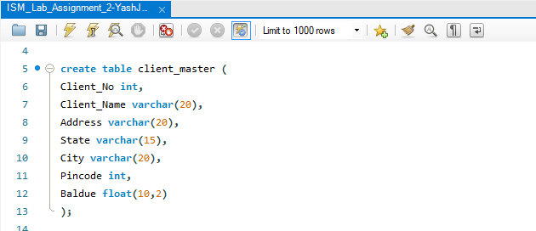

**Task 2: Insert any 5 rows in the above columns.**

The given task can be completed using the **‘insert into’** command.

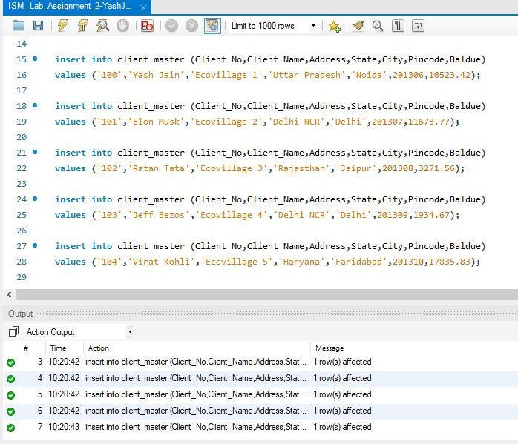

**Task 3: Select the whole table**

This task can be completed by using the command **‘select’**.

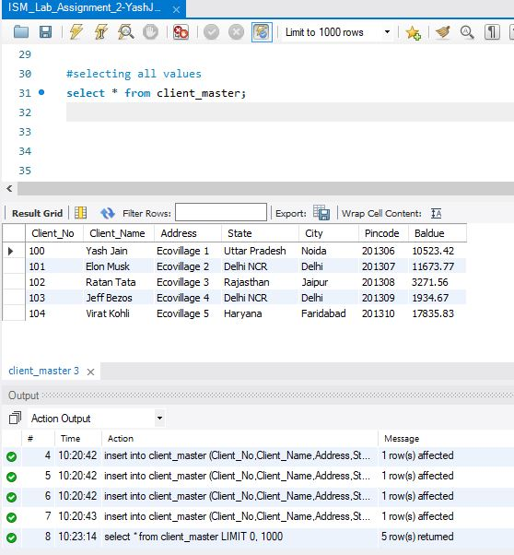

**Task 4: Display all the details where city is Delhi**

This task can be completed by using the command **‘select’**, with the **‘where’** clause. Here, we will use ‘where’ clause for filtering the data of the table. After select, we write the names of columns separated by commas. The syntax for this clause is :

select column1,column2,. . from table where columname=’value’; (for specific columns)

select * from table where columname=’value’; (for all columns)

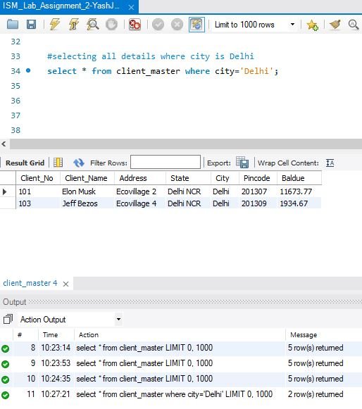

Note: The statement after ‘where’, when you put the specific column value, we put inverted commas (‘’) only when the data type of the column is char or varchar.

**Task 5: Display the names of the client who belongs to ‘Haryana’**

This task can be completed by using the command **‘select’**, with the **‘where’** clause.

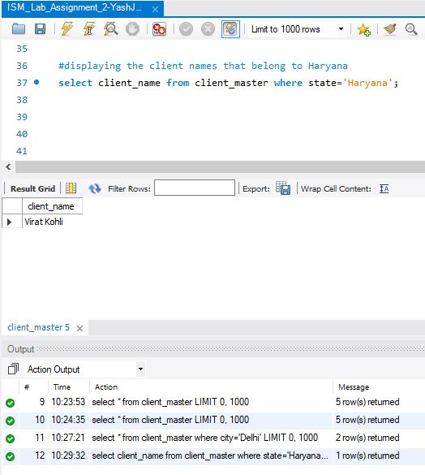

**Task 6: Display the Client_No. and name whose Baldue is greater than “5000”.**

This task can be completed by using the command **‘select’**, with the **‘where’** clause. Here, since the column datatype is ‘int’, we won’t use inverted commas(‘’). Also, since the comparison parameter is greater than or equal to’, we would use ‘>=’ after ‘where’ clause.

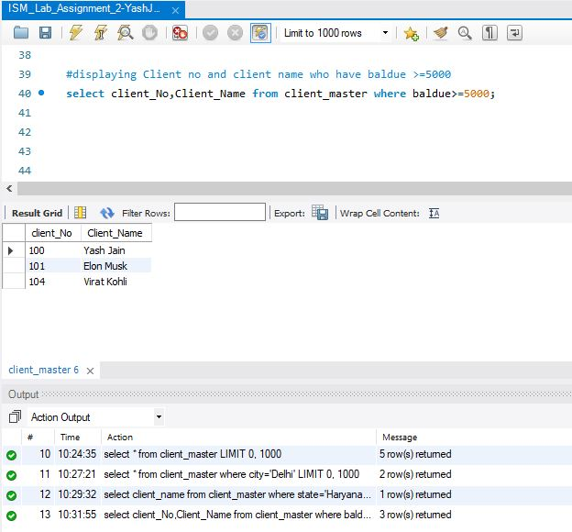

**Task 7: Display the client_no., city and pincode who belongs to Delhi**

This task can be completed by using the command **‘select’**, with the **‘where’** clause.

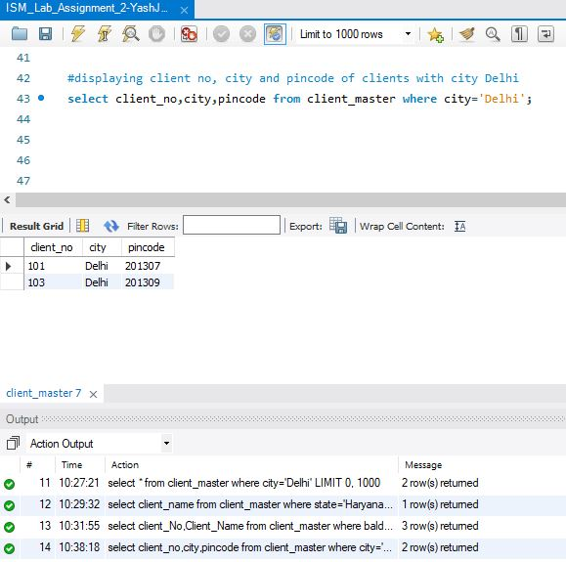

**Task 8: Display the name and Baldue of those clients who belongs to Rajasthan**

This task can be completed by using the command **‘select’**, with the **‘where’** clause.

